Boy in intensive care after mum gave him ibuprofen for a cold: Rare allergy left him covered in agonising blisters
- Over-the-counter medicine almost cost Max Brown, 13, his life
- Reaction became so bad he screamed in pain when anyone touched him
- Was diagnosed with Stevens-Johnson Syndrome (SJS)
- Condition causes cells embedded in the skin to die before shedding
- Spent more than a month in hospital and his mother, Nicola Wheatley, was warned he may not make it
By Daily Mail Reporter
PUBLISHED: 17:33 EST, 23 February 2014 | UPDATED: 17:33 EST, 23 February 2014

When 13-year-old Max Brown came down with a cold, his worried mother gave him ibuprofen.
But the over-the-counter medication almost cost him his life after a violent allergic reaction left him covered in severe blisters and his lips turned black.
It became so bad that he screamed in pain when anyone touched him and was left slipping in and out of consciousness as he fought for his life in intensive care.
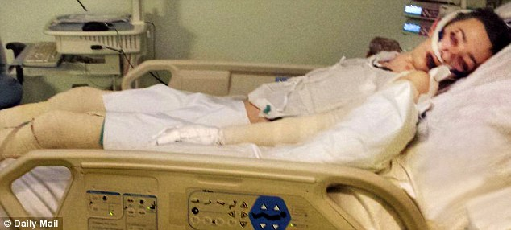
In bandages: Max Brown, 13, on a ventilator in intensive care after his severe reaction to the over-the-counter medicine
Max was diagnosed with Stevens-Johnson Syndrome (SJS), a condition which causes the cells in the top layer of the skin to die before shedding.
He spent just over a month in hospital in November, during which his devastated mother Nichola Wheatley was warned he could die.
‘The doctors were 100 per cent certain that the ibuprofen caused Max’s reaction,’ she said at her home in Esher, Surrey, yesterday. ‘I didn’t know he was allergic, he had taken ibuprofen before years ago. It was the biggest shock of my life.’
The traumatic events started when Miss Wheatley, a 45-year-old teaching assistant, noticed that Max was not well so kept him off school for a couple of days.
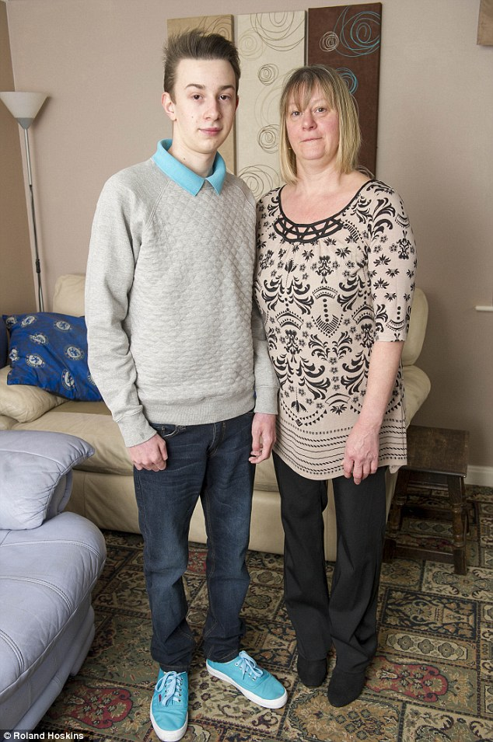
Life-threatening: His mother Nicola Wheatley was told Max could die as a result of his extreme reaction
Thinking he had a cold, she began giving him standard doses of liquid ibuprofen. But within a matter of days his entire body was covered in rashes and blisters. She took him to her GP, who told her to take Max straight to hospital.
He was admitted to hospital but at first doctors were baffled by what was wrong. By this time his skin was blistering and peeling off, while his lips were swollen, black and crusted.
Miss Wheatley said: ‘It is the most horrific thing for a parent to have to see their child suffer the way Max has. I was devastated.
‘My son was so ill and I couldn’t hold him or kiss him. He was screaming because his skin was so raw. I felt helpless. Nobody could tell us what was happening because nobody knew.’
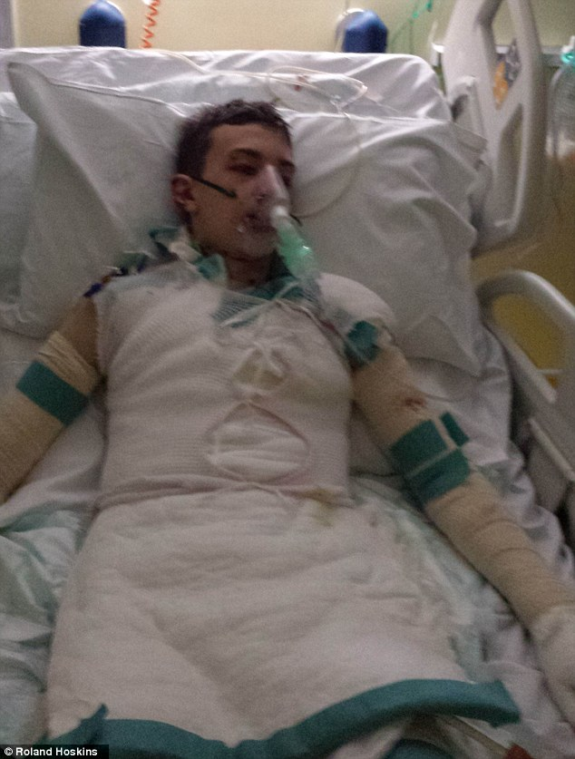
Treatment: He spent a month in hospital after he was diagnosed Stevens-Johnson Syndrome (SJS)
Max was taken to a specialist unit for more tests and was diagnosed with Stevens-Johnson Syndrome. After a week in hospital his condition had deteriorated so much that he couldn’t open his eyes because of the scabbing and his whole body was blistered, raw and peeling.
Miss Wheatley said: ‘That was the worst thing for me. I had no idea if he was going to get better or not. I was stuck in limbo watching my son’s health deteriorate.’ Max was then taken into intensive care at another hospital where he was put on morphine and antibiotics.
His weight dropped to six stone and his mother said doctors did not know whether he would survive. ‘Max needed help breathing and had bandages covering his entire body,’ she said.
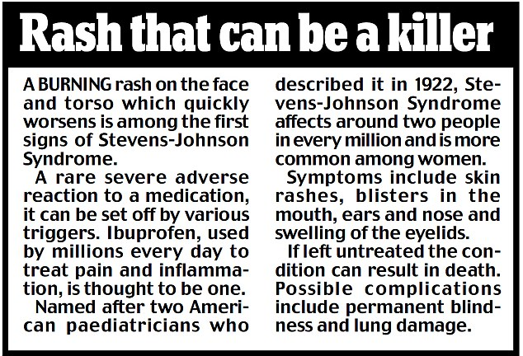
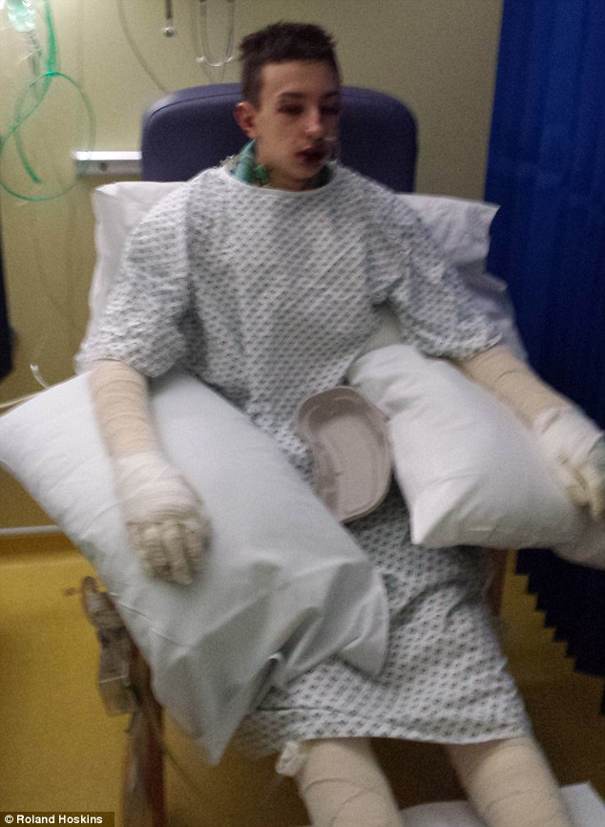
Covered up: His weight dropped to six stone and his mother said doctors did not know whether he would survive
‘Every day he would have to have the bandages changed to stop infection, but I could see he was in agony whenever anyone touched his skin. He was drifting in and out of consciousness.’
With no known cure, the disorder was left to run its course and after four weeks his skin began to clear and he was allowed home.
Miss Wheatley said: ‘I am so proud of him for pulling through. He will have the scars for the rest of his life, but it is a small price to pay when he nearly died.
‘More research needs to be done to help SJS sufferers. It is a horrific illness and causes so much disfigurement and pain.’
Well: The disorder was left to run its course and after four weeks his skin began to clear and he was allowed home to be with his family

