A Family’s Shared Defect Sheds Light on the Human Genome
Basics
By NATALIE ANGIER JAN. 9, 2017

They said it was their family curse: a rare congenital deformity called syndactyly, in which the thumb and index finger are fused together on one or both hands. Ten members of the extended clan were affected, and with each new birth, they told Stefan Mundlos of the Max Planck Institute for Molecular Genetics, the first question was always: “How are the baby’s hands? Are they normal?”
Afflicted relatives described feeling like outcasts in their village, convinced that their “strange fingers” repulsed everybody they knew — including their unaffected kin. “One woman told me that she never received a hug from her father,” Dr. Mundlos said. “He avoided her.”
The family, under promise of anonymity, is taking part in a study by Dr. Mundlos and his colleagues of the origin and development of limb malformations. And while the researchers cannot yet offer a way to prevent syndactyly, or to entirely correct it through surgery, Dr. Mundlos has sought to replace the notion of a family curse with “a rational answer for their condition,” he said — and maybe a touch of pioneers’ pride.
The scientists have traced the family’s limb anomaly to a novel class of genetic defects unlike any seen before, a finding with profound implications for understanding a raft of heretofore mysterious diseases.
The mutations affect a newly discovered design feature of the DNA molecule called topologically associating domains, or TADs. It turns out that the vast informational expanse of the genome is divvied up into a series of manageable, parochial and law-abiding neighborhoods with strict nucleic partitions between them — each one a TAD.
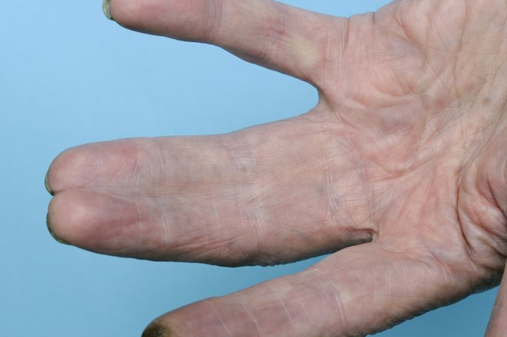
The hand of a woman with syndactyly, the congenital fusion of fingers. The deformity may range from a slight degree of webbing to almost complete fusion as shown here. CreditSPL/Science Source
Breach a TAD barrier, and you end up with the molecular equivalent of that famous final scene in Mel Brooks’s comedy, “Blazing Saddles,” when the cowboy actors from one movie set burst through a wall and onto the rehearsal stage of a campy Fred Astaire-style musical. Soon fists, top hats and cream pies are flying.
By studying TADs, researchers hope to better fathom the deep structure of the human genome, in real time and three dimensions, and to determine how a quivering, mucilaginous string of some three-billion chemical subunits that would measure more than six-feet long if stretched out nonetheless can be coiled and compressed down to four-10,000ths of an inch, the width of a cell nucleus — and still keep its operational wits about it.
“DNA is a super-long molecule packed into a very small space, and it’s clear that it’s not packed randomly,” Dr. Mundlos said. “It follows a very intricate and controlled packing mechanism, and TADs are a major part of the folding protocol.”
For much of the past 50 years, genetic research has focused on DNA as a kind of computer code, a sequence of genetic “letters” that inscribe instructions for piecing together amino acids into proteins, which in turn do the work of keeping us alive.

Read Between the Folds
Most of the genetic diseases deciphered to date have been linked to mishaps in one or another protein recipe. Scanning the DNA of patients with Duchenne muscular dystrophy, for example, scientists have identified telltale glitches in the gene that encodes dystrophin, a protein critical to muscle stability.
At the root of Huntington’s disease, which killed the folk singer Woody Guthrie, are short, repeated bits of nucleic nonsense sullying the code for huntingtin, an important brain protein. The mutant product that results soon shatters into neurotoxic shards.
Yet researchers soon realized there was much more to the genome than the protein codes it enfolded. “We were caught up in the idea of genetic information being linear and one-dimensional,” said Job Dekker, a biologist at the University of Massachusetts Medical School.
For one thing, as the sequencing of the complete human genome revealed, the portions devoted to specifying the components of hemoglobin, collagen, pepsin and other proteins account for just a tiny fraction of the whole, maybe 3 percent of human DNA’s three billion chemical bases.
And there was the restless physicality of the genome, the way it arranged itself during cell division into 23 spindly pairs of chromosomes that could be stained and studied under a microscope, and then somehow, when cell replication was through, merged back together into a baffling, ever-wriggling ball of chromatin — DNA wrapped in a protective packaging of histone proteins.
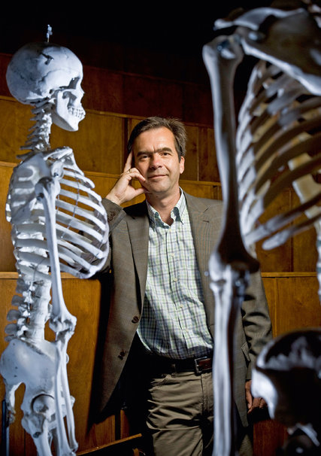
Stefan Mundlos of the Max Planck Institute for Molecular Genetics in Germany studies the origin and development of limb malformations, some of which are caused by a novel class of genetic defects.CreditNorbert Michalke/Max Planck Institute for Molecular Genetics, Berlin
What was the link, scientists wondered, between the shape and animation of the DNA molecule at any given moment, in any given cell — and every cell has its own copy of the genome — and the relative mouthiness or muteness of the genetic information the DNA holds?
“We realized that in order to understand how genetic information is controlled, we had to figure out how DNA was folded in space,” said Bing Ren of the University of California, San Diego.
Using a breakthrough technology developed by Dr. Dekker and his colleagues called chromosome conformation capture, researchers lately have made progress in tracking the deep structure of DNA. In this approach, chromatin is chemically “frozen” in place, enzymatically chopped up and labeled, and then allowed to reassemble.
The pieces that find each other again, scientists have determined, are those that were physically contiguous in the first place — only now all their positions and relationships are clearly marked.
Through chromosome conformation studies and related research, scientists have discovered the genome is organized into about 2,000 jurisdictions, and they are beginning to understand how these TADs operate.
As with city neighborhoods, TADs come in a range of sizes, from tiny walkable zones a few dozen DNA subunits long to TADs that sprawl over tens of thousands of bases and you’re better off taking the subway. TAD borders serve as folding instructions for DNA. “They’re like the dotted lines on a paper model kit,” Dr. Dekker said.
TAD boundaries also dictate the rules of genetic engagement.
Scientists have long known that protein codes are controlled by an assortment of genetic switches and enhancers — noncoding sequences designed to flick protein production on, pump it into high gear and muzzle it back down again. The new research indicates that switches and enhancers act only on those genes, those protein codes, stationed within their own precincts.
Because TADs can be quite large, the way the Upper West Side of Manhattan comprises an area of about 250 square blocks, a genetic enhancer located at the equivalent of, say, Lincoln Center on West 65th Street, can amplify the activity of a gene positioned at the Cathedral of St. John the Divine, 45 blocks north.
But under normal circumstances, one thing an Upper West Side enhancer will not do is reach across town to twiddle genes residing on the Upper East Side.
Photo
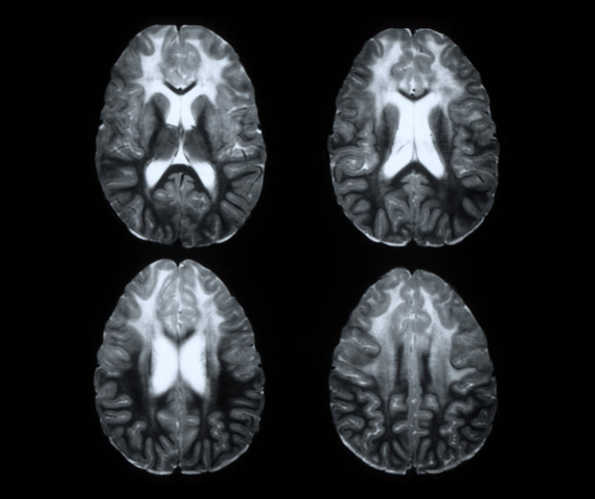
Scientists have learned that disruptions of the genome’s boundaries may cause syndactyly and other diseases, including some pediatric brain disorders that affect the brain’s white matter.CreditLiving Art Enterprises, LLC/Science Source
“Genes and regulatory elements are like people,” Dr. Dekker said. “They care about and communicate with those in their own domain, and they ignore everything else.”

Breaking Boundaries
What exactly do these boundaries consist of, that manage to both direct the proper folding of the DNA molecule and prevent cross talk between genes and gene switches in different domains? Scientists are not entirely sure, but preliminary results indicate that the boundaries are DNA sequences that attract the attention of sticky, roughly circular proteins called cohesin and CTCF, which adhere thickly to the boundary sequences like insulating tape.
Between those boundary points, those clusters of insulating proteins, the chromatin strand can loop up and over like the ribbon in a birthday bow, allowing genetic elements distributed along the ribbon to touch and interact with one another. But the insulating proteins constrain the movement of each chromatin ribbon, said Richard A. Young of the Whitehead Institute for Biomedical Research, and keep it from getting entangled with neighboring loops — and the genes and regulatory elements located thereon.
The best evidence for the importance of TADs is to see what happens when they break down. Researchers have lately linked a number of disorders to a loss of boundaries between genomic domains, including cancers of the colon, esophagus, brain and blood.
In such cases, scientists have failed to find mutations in any of the protein-coding sequences commonly associated with the malignancies, but instead identified DNA damage that appeared to shuffle around or eliminate TAD boundaries. As a result, enhancers from neighboring estates suddenly had access to genes they were not meant to activate.
Reporting in the journal Science, Dr. Young and his colleagues described a case of leukemia in which a binding site for insulator proteins had been altered not far from a gene called TAL1, which if improperly activated is known to cause leukemia. In this instance, disruption of the nearby binding site, Dr. Young said, “broke up the neighborhood and allowed an outside enhancer to push TAL1 to the point of tumorigenesis,” the production of tumors.
Now that researchers know what to look for, he said, TAD disruptions may prove to be a common cause of cancer. The same may be true of developmental disorders — like syndactyly.
In journals like Cell and Nature, Dr. Mundlos and his co-workers described their studies of congenital limb malformations in both humans and mice. The researchers have detected major TAD boundary disruptions that allowed the wrong control elements to stimulate muscle genes at the wrong time and in the wrong tissue.
“If a muscle gene turns on in the cartilage of developing digits,” Dr. Mundlos said, “you get malformations.”
Edith Heard, director of the genetics and developmental biology department at the Institut Curie in France, who with Dr. Dekker coined the term TAD, said that while researchers were just beginning to get a handle on the architecture of DNA, “suddenly a lot of things are falling into place. We’re coming into a renaissance time for understanding how the genome works.”

