Spring 2020: Chp5 & 6 Deitel: Functions and Arrays : pr66
Deitel/Subbarao: Modified 02 17 2020: Copy right extended thru 2020

// : Chp5 & 6 Deitel: Functions and Arrays: Modified AND Extended THRU Spring 2020
// Subbarao V Wunnava: Courtesy Deitel: Setting up and Math operations on Arrays

#include <stdio.h>
#include <stdlib.h>
#include <math.h>

//declare printArray function and addArray functions and subtractArrayColumn function
void printArray ( int x[3][3]); //function proto type to print array
void addArray (int y[3][3], int z[3][3]); // function proto type to add arrays
void subtractArrayColumn (int p[3][3], int q[3][3]); //function proto type to subtract arrays by columns

int main(void)
{
//initialize A and B arrays
int A [3][3] = { {2, 4, 6 }, {1, 3, 5}, {7, 8, 9} };
int B [3][3] = { {2, 7}, {4, 3, 1}, {9} };
int C [3][3] = { {1}, {1,2}, {2,4} };
//printing arrays A, B, and C by rows
printf ("\n\a Subbarao/Deitel Chp 5&6: Functions: Multi Dimensional Arrays: \n");
printf ("\n\a pgs 195-250 F14 2880 09 11 2014 Modified 09 18 2014 : \n");
puts("\n Array A by row :\n ");
printArray (A);

puts("\n Array B by row :\n ");
printArray (B);

puts("\n Array C by row :\n ");
printArray (C);
// adding and subtracting arrays
puts("\n add A and B arrays :\n ");
addArray (A,B);
puts("\n add B and C arrays :\n ");
addArray (B,C);
puts("\n subtract B and C arrays by columns :\n ");
subtractArrayColumn (B,C);
} // end main

//start of printArray to output the Arrays
void printArray ( int x[3][3])
{
size_t r; // row counter
size_t c; // column counter
// loop through rows
for ( r = 0; r <=2; ++r) //outer loop for rows
{
for ( c= 0; c <=2; ++c) // inner loop for columns
{
printf (" \t %d", x[r][c]);
}
printf ("\n\a" );
}
} //end printArray function

// start of the addArray function to add specified arrays
void addArray ( int y[3][3], int z[3][3])
{
size_t l; // row counter
size_t m; // column counter
// loop through rows
for ( l = 0; l <=2; ++l) //outer loop for rows
{
for ( m= 0; m <=2; ++m) // inner loop for columns
{
printf (" \t %d", (y[l][m]+ z[l][m]));
}
printf ("\n\a" );
}
} //end addArray function

// start of the subtractArray function to subtract specified arrays by columns
void subtractArrayColumn ( int p[3][3], int q[3][3])
{
size_t k; // row counter
size_t j; // column counter
// loop through rows and then columns
for ( k = 0; k <=2; ++k) //outer loop for rows
{
for ( j= 0; j <=2; ++j) // inner loop for columns
{
printf (" \t %d", (p[k][j]- q[k][j]));
}
printf ("\n\a" );
}
// loop through columns and then rows
printf ("\n loop through columns and then rows \n" );
for ( k = 0; k <=2; ++k) //outer loop for rows
{
for ( j= 0; j <=2; ++j) // inner loop for columns
{
printf (" \t %d", (p[j][k]- q[j][k]));
}
printf ("\n\a" );
}

// loop through columns and then rows in criss cross way
printf ("\n loop through columns and then rows in criss cross way \n" );
for ( k = 0; k <=2; ++k) //outer loop for rows
{
for ( j= 0; j <=2; ++j) // inner loop for columns
{
printf (" \t %d", (p[j][k]- q[k][j]));
}
printf ("\n\a" );
}
} //end subtractArrayColumn function

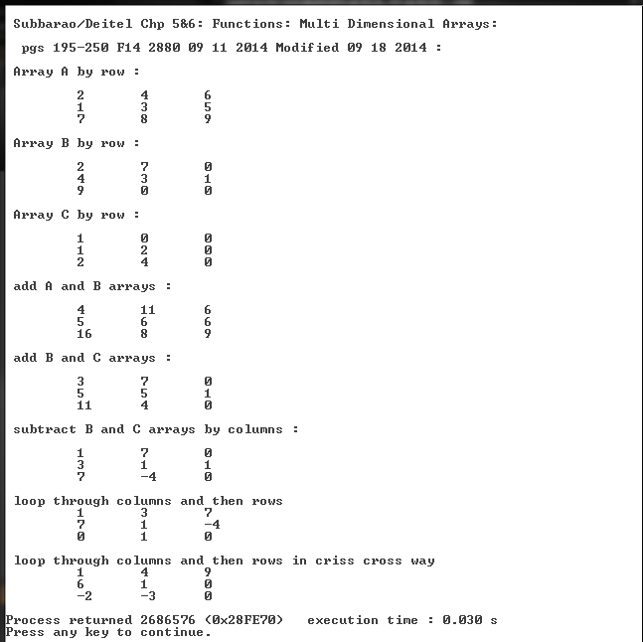

6.19 (Dice Rolling) Write a program that simulates the rolling of two dice. The program should
use rand twice to roll the first die and second die, respectively. The sum of the two values should
then be calculated. [Note: Because each die can show an integer value from 1 to 6, then the sum of
the two values will vary from 2 to 12, with 7 being the most frequent sum and 2 and 12 the least
frequent sums.] Figure 6.24 shows the 36 possible combinations of the two dice. Your program
should roll the two dice 36,000 times. Use a single-subscripted array to tally the numbers of times
each possible sum appears. Print the results in a tabular format. Also, determine if the totals are
reasonable; i.e., there are six ways to roll a 7, so approximately one-sixth of all the rolls should be 7.
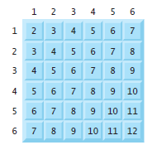
// Exercise 6.19 Solution: Deitel/Subbarao Modified Spring 2020: 02 17 2020
// EEL 2880 Original Patent 09 18 2016/Modified 02 17 2020 Random Dice rolling
// and array computations

#include <stdio.h>
#include <stdlib.h>
#include <time.h>

int main( void )
{
unsigned int i; // loop counter
unsigned int j; // loop counter
unsigned int x; // first die
unsigned int y; // second die
unsigned int sum[ 13 ] = { 0 }; // count occurrences of each combination

// array expected contains counts for the expected
// number of times each sum occurs in 36 rolls of the dice
unsigned int expected[ 13 ] = {0, 0, 1, 2, 3, 4, 5, 6, 5, 4, 3, 2, 1};
printf("\n\n\a\a EEL 2880 Fall 2013 09 18 2013: Random Dice rolling \n\n ");
printf(" and array computations: Problem 6.19 Deitel/Subbarao \n\n");

srand( time( NULL ) ); // seed random number generator

// roll dice 36,000 times using -for loop 1-
for ( i = 1; i <= 36000; ++i )
{
x = 1 + rand() % 6;
y = 1 + rand() % 6;
++sum[ x + y ];
} // end for-1

printf ("\n\t final i value: %u \n\n ", i);
printf( "%10s%10s%10s%10s\n", "Sum", "Total", "Expected", "Actual" );

// display results of rolling dice using for loop 2
for ( j = 2; j <= 12; ++j )
{
printf( "%10u%10u%9.3f%%%9.3f%%\n", j, sum[ j ],
100.0 * expected[ j ] / 36, 100.0 * sum[ j ] / 36000 );
} // end for-2
system("PAUSE");
} // end main

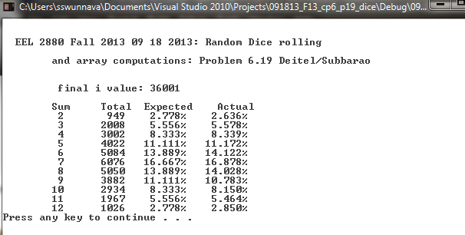

EEL 2880: Introduction to Machine Code and Micro Architecture: Spring 2020:
Ref: Chapters 6 and 7 Deitel: : Arrays&Pointers Fall 2016 Updated 02 17 2020
Inside a microprocessor/computer system, nearly 80-85 % of the time, data transfers take place on the system bus. The machine code operation controls the data flow and any arithmetic and logical operations.
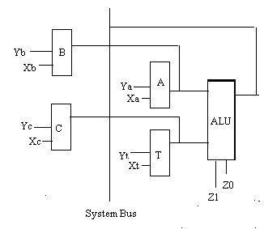Courtesy: INTEL CORPORATION
A: Accumulator T : Temporary Register; ALU: Arithmetic Logic Unit B & C are registers
Y and X are data transfer control signals and Z1 Z0 are ALU control signals for machine code
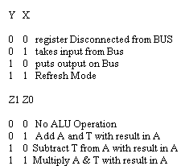
Control word is: Z1 Z0 Ya Xa Yt Xt Yb Xb Yc Xc Hex Code
A B 0 0 0 1 0 0 1 0 0 0 048
T C 0 0 0 0 0 1 0 0 1 0 012

A A+T 0 1 0 1 0 0 0 0 0 0 140
B A 0 0 1 0 0 0 0 1 0 0 084

The above operation is B = B+C in higher level languages

