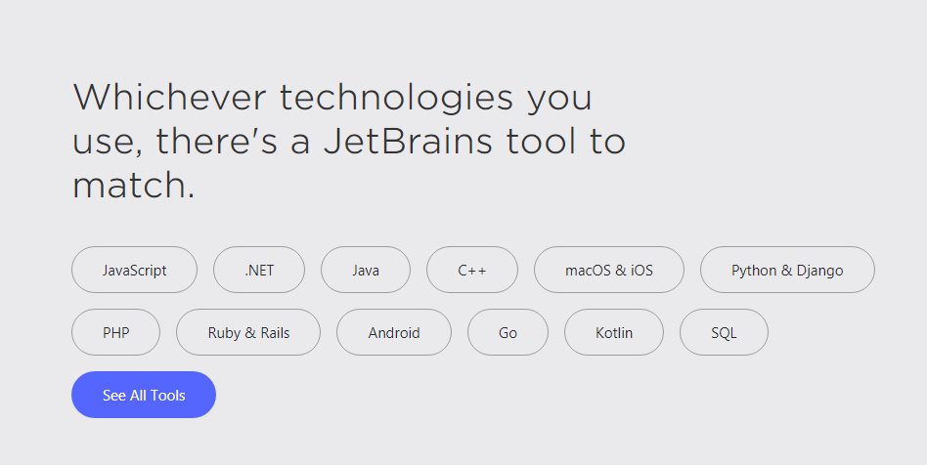

Provided by Mr. Carlos Velez Fall 2019 for Software Engineering Courses: 2880 and above
Subbarao V Wunnava October 2019

