EEL 2880: Using Random structures with Software platforms to generate
Entertainment activities such as Card Games, prediction schemes,
Fall 2018/updated Fall 2019: Ref: Deitel How to Program C
Eric and Dennis and Subbarao Wunnava: FIU ECE Department: 10 27 2019
- //ELECTRICAL and Computer Engineering: FIU:
- //EEL 2880: Software Engineering: Subbarao Wunnava
- //Using Random Timing and Distribution Systems:

- //04 19 2016: Card Shuffle Program: Courtesy: Eric and Dennis 2880: updated Fall 2019

- #include <stdio.h>
- #include <stdlib.h>
- #include <time.h>

- #define CARDS 52
- #define FACES 13

- //card structure defiition
- struct card {
- const char *face; // define pointer face
- const char *suit; // define pointer face
- };

- typedef struct card Card; // new type name for struct card

- // prototypes All functions defined
- void fillDeck( Card * const wDeck, const char * wFace[],
- const char * wSuit[] );
- void shuffle( Card * const wDeck );
- void deal( const Card *const wDeck );

- int main( void )
- {
- Card deck [ CARDS ]; //define array of Cards

- //initialize array of pointers
- const char * face[] = { "Ace" , "Deuce" , "Three" , "Four" , "Five" , "Six" , "Seven" , "Eight" , "Nine" , "Ten" , "Jack" , "Queen" , "King"};

- // initialize array of pointers
- const char *suit[] = { "Hearts" , "Diamonds" , "Clubs" , "Spades"};

- srand( time( NULL) ); //randomize

- fillDeck( deck, face, suit ); //load the deck with Cards
- shuffle( deck ); // put Cards in random order
- deal( deck ); // deal all 52 Cards
- } // end main

- // place strings into Card Structures
- void fillDeck( Card * const wDeck, const char * wFace [],
- const char * wSuit[] )
- {
- size_t i; // counter

- // loop through wDeck
- for (i = 0; i < CARDS; ++i ) {
- wDeck [ i ] . face = wFace[ i % FACES];
- wDeck [ i ] . suit = wSuit[ i / FACES];
- } // end for
- } // end function fillDeck

- // random shuffle of cards
- // shuffle cards
- void shuffle( Card * const wDeck )
- {
- size_t i; // counter
- size_t j; // variable to hold random variable between 0-51
- Card temp; // define teporary structure for swapping Cards
- // loop through wDeck randoml swapping Cards
- for ( i = 0; i < CARDS; ++i) {
- j = rand () % CARDS;
- temp = wDeck[ i ];
- wDeck[ i ] = wDeck [ j ];
- wDeck[ j ] = temp;
- } // end for
- }// end function shuffle

- // deal cards
- void deal( const Card * const Deck)
- {
- size_t i; // counter

- // loop through wDeck
- for ( i = 0; i < CARDS; ++i ) {
- printf ("%5s of %-8s%s", Deck[ i ].face, Deck[ i ].suit,
- (i + 1 ) % 4 ? " " : "\n" );
- } // end for
- } // end function deal

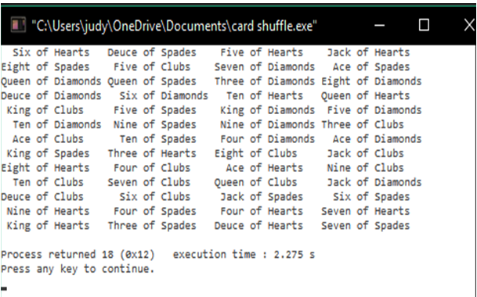
09 12 2018: Courtesy: Eric and Dennis from EEL 2880 Software Engineering Class
Updated Fall 2019: Used in EEL 2880 Software Engineering
and associated C and C++ classes

