EEL 2880: Software Techniques: Modified Fall 2019: 10 24 2019
Dr. Subbarao V Wunnava: Chp 8_9: Strings and Security:
Copyright extended thru 2019
8.5 (Character Testing) Write a program that inputs a character from the keyboard and tests the character with each of the functions in the character-handling library. The program should print the value returned by each function.

// Exercise 8.5 Solution: Subbarao/Deitel 10 18 2019 EEL 2880: Problem 8.5 modified: String
// string functions copy right extended thru 2019
#include <stdio.h>
#include <ctype.h>
#include <math.h>
int main( void )
{
int c; // character input by user
printf( "%s", "Enter a character: " );
c = getchar();
// test each function of the character-handling library
printf("\n\a the ASCII numeric value of the entered character %c: %d \n\n\a ", c, c);
printf( "isdigit( \'%c\' ) = %d\n\a", c, isdigit( c ) );
printf( "isalpha( \'%c\' ) = %d\n\a", c, isalpha( c ) );
printf( "isalnum( \'%c\' ) = %d\n\a", c, isalnum( c ) );
printf( "isxdigit( \'%c\' ) = %d\n\a", c, isxdigit( c ) );
printf( "islower( \'%c\' ) = %d\n\a", c, islower( c ) );
printf( "isupper( \'%c\' ) = %d\n\a", c, isupper( c ) );
printf( "tolower( \'%c\' ) = %d\n\a", c, tolower( c ) );
printf( "toupper( \'%c\' ) = %d\n\a", c, toupper( c ) );
printf( "isspace( \'%c\' ) = %d\n\a", c, isspace( c ) );
printf( "iscntrl( \'%c\' ) = %d\n\a", c, iscntrl( c ) );
printf( "ispunct( \'%c\' ) = %d\n\a", c, ispunct( c ) );
printf( "isprint( \'%c\' ) = %d\n\a", c, isprint( c ) );
printf( "isgraph( \'%c\' ) = %d\n\a", c, isgraph( c ) );
system("PAUSE");
} // end main

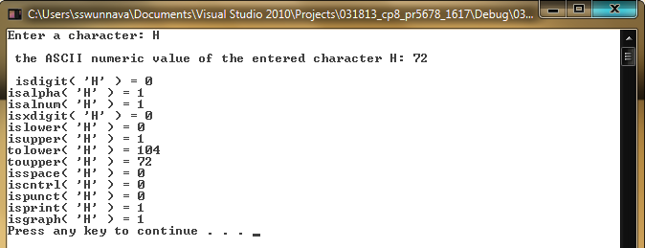

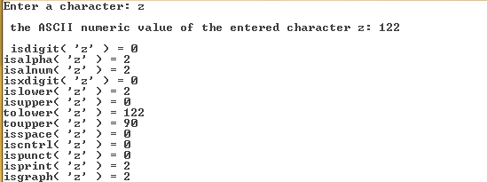

8.6 (Displaying Strings in Uppercase and Lowercase) Write a program that inputs a line of text into char array s[100]. Output the line in uppercase letters and in lowercase letters.

// Exercise 8.6 Solution: Upper and Lower Case letters
// Deitel/Subbarao EEL 2880 Fall 2019 10 22 2019
#include <stdio.h>
#include <ctype.h>

int main( void )
{
char s[ 100 ]; // define character array of size 100
size_t i; // loop counter
// use gets to get text from user
puts( "Enter a line of text: \a\a\n\n" );
fgets( s, 100, stdin );
puts( "\n\aThe line in uppercase is:" );
// convert each character to uppercase and output
for ( i = 0; s[ i ] != '\0'; ++i )
{
printf( "%c", toupper( s[ i ] ) );
} // end for Uppercase characters
puts("");

printf( " Uppercase ASCII code for the entered string \n\n\a\a");

for ( i = 0; s[ i ] != '\0'; ++i )
{
printf( " %c:%d",toupper(s[ i ]),toupper(s[ i ]));
} // end for Uppercase ASCII code

puts( "\n\n\a The line in lowercase is:" );

// convert each character to lowercase and output
for ( i = 0; s[ i ] != '\0'; ++i )
{
printf( "%c", tolower( s[ i ] ) );
} // end for Lowercase characters
printf( " Lowercase ASCII code for the entered string \n\n\a\a");

for ( i = 0; s[ i ] != '\0'; ++i )
{
printf( " %c:%d", tolower( s[ i ]),tolower( s[ i ]) );
} // end for Lowercase ASCII

printf( "\n \a\t The final value of loop variable 'i' is:%d\n", i);
puts( "" );
system("PAUSE");
} // end main

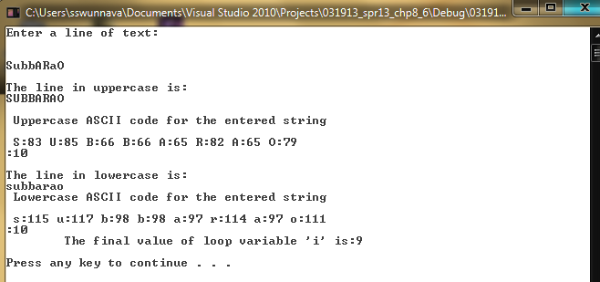

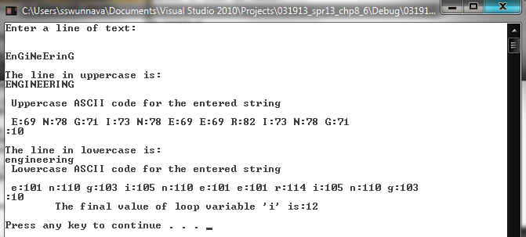

8.20 (Counting the Number of Words in a String) Write a program that inputs several lines oftext and uses strtok to count the total number of words. Assume that the words are separated by either spaces or newline characters.

// Exercise 8.20 Solution: Deitel/Subbarao 10 11 2019: Counting words
#include <stdio.h>
#include <string.h>

int main( void )
{
char text[ 4 ][ 80 ]; // text entered by user upto 4 lines and . 80 characters a line
char *tokenPtr; // pointer to current token
size_t i; // loop counter
int counter = 0; // token counter

puts( "Enter 4 lines of text:\a\n " );

// read 4 lines of text
for ( i = 0; i <= 3; ++i )
{
fgets( &text[ i ][ 0 ], 80, stdin );
} // end for loop 1 for lines of text

// loop through 4 lines of text

for ( i = 0; i <= 3; ++i )
{
// get first token
tokenPtr = strtok( &text[ i ][ 0 ], " \n" );
// while tokenPtr does not equal NULL
while ( tokenPtr )
{
++counter;
tokenPtr = strtok( NULL, " \n" ); // get next token
} // end while
} // end for getting tokens

printf( "\n\a\a The total number of words is %d\n\n", counter );
system("PAUSE");
} // end main

