EEL 2880: Spr 2020: 03_12_2020: Dynamic Coding and Data Security
Deitel/Subbarao: Reference: Chapters 6, 7, 8, and 9 and 10
Copy Right extended through 2020

Introduction: In the present times, with all the information transfer on Internet and wireless, data security is being compromised. All the institutions, governments, bio and other industries are heavily concerned about the data and individual security. While there is nothing absolute security, several methods are being devised to protect the data and information security. Some of the methodologies are: Data Encryption Schemes [DES], where mathematical process takes the base information through iterations to modify the content; Stegenography Schemes, where in the digital scenario, some bits of information are randomly replaced by the data elements and mask the information in a big digital platform; Dynamic codining Schemes, where the number codes of characters are dynamically changed and the modified information is being communicated; and several such schemes. In all these methodologies, the reverse key should be available for the proper individuals to be able to decode and obtain the original message. To protect the nature of the data security, whatever methodology is being followed, should be made dynamic, so that it would not be broken.

Data security is becoming increasingly demanding activity in all the fileds of human existance. Here is a sample of dynamic coding scheme:

// Data Security: Dynamic coding: Chaps 6-9 and 10
// Deitel/Subbarao EEL 2880: Modified 10 02 2018
#include <stdio.h>
#include <stdlib.h>
#include <ctype.h>
#include <string.h>

int main()
{
char s[ 100 ]; // define character array of size 100
size_t i; // loop counter
puts( "\n\a Data Security: Chps 6-9; Dynamic coding:\n " );
puts( "\n\a Deitel/Subbarao EEL 2880 F 2014 10 21 2014 \n " );

// use gets to get text from user
puts( "Enter a line of text: \a\n" );
fgets( s, 100, stdin );
puts( "\n\aThe line in uppercase is: \n" );

// convert each character to ASCII uppercase and output
for ( i = 0; s[ i ] != '\0'; ++i )
{
printf( "%c", toupper( s[ i ]) );
} // end for Uppercase characters

puts("\n upper case ASCII code for the characters \n");
for ( i = 0; s[ i ] != '\0'; ++i )
{
printf(" %c:%d",toupper(s[ i ]),toupper(s[ i ]));
} // end for Uppercase ASCII

// convert each character to modified ASCII uppercase and output
puts( "\n\aThe line in modified uppercase with progressively higher ASCII:\n" );
for ( i = 0; s[ i ] != '\0'; ++i )
{
printf( "%c", toupper( s[ i ] + (i+1)) );
} // end for modified Uppercase characters

puts("");
printf( " \n Uppercase modified ASCII code for the entered string \n\n\a");
for ( i = 0; s[ i ] != '\0'; ++i )
{
printf( " %c:%d",toupper(s[ i ] + (i+1)),toupper(s[ i ] +(i+1)));
} // end for modified Uppercase ASCII code

printf( " \n\n Lower case for the entered string \n\n\a");
for ( i = 0; s[ i ] != '\0'; ++i )
{
printf( "%c",tolower (s[ i ]));
} // end for Lowercase ASCII

printf( " \n Lower case ASCII for the entered string \n\n\a");
for ( i = 0; s[ i ] != '\0'; ++i )
{
printf( " %c:%d",tolower( s[ i ]),tolower( s[ i ]));
} // end for Lowercase ASCII

printf( " \n modified Lower case ASCII for the entered string \n\n\a");
for ( i = 0; s[ i ] != '\0'; ++i )
{
printf( " %c:%d", tolower ( s[ i ] - (i+1)),tolower( s[ i ] - (i+1)));
} // end for modified Lowercase ASCII

// convert each character to modified ASCII uppercase and output
puts( "\n\aThe line in modified lowercase with progressively lower ASCII:\n" );
for ( i = 0; s[ i ] != '\0'; ++i )
{
printf( "%c", tolower( s[ i ] - (i+1)) );
} // end for modified lower characters
puts("");

printf( "\n \a\t The final value of loop variable 'i' is:%d\n", i);
puts( "" );

} // end main

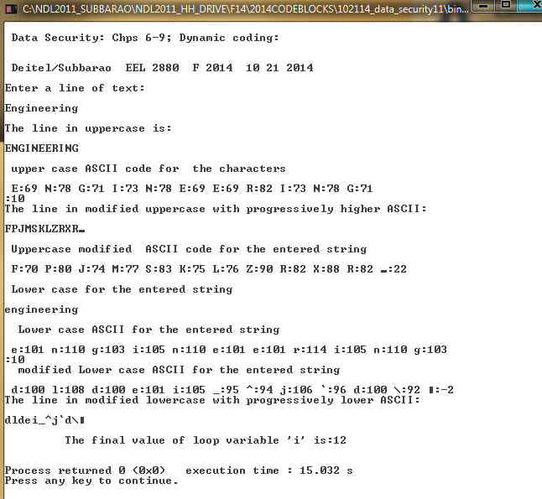

ASCII Hex Symbol  0 1 2 3 4 5 6 7 8 9 10 11 12 13 14 15 0 1 2 3 4 5 6 7 8 9 A B C D E F NUL SOH STX ETX EOT ENQ ACK BEL BS TAB LF VT FF CR SO SI | ASCII Hex Symbol  16 17 18 19 20 21 22 23 24 25 26 27 28 29 30 31 10 11 12 13 14 15 16 17 18 19 1A 1B 1C 1D 1E 1F DLE DC1 DC2 DC3 DC4 NAK SYN ETB CAN EM SUB ESC FS GS RS US | ASCII Hex Symbol  32 33 34 35 36 37 38 39 40 41 42 43 44 45 46 47 20 21 22 23 24 25 26 27 28 29 2A 2B 2C 2D 2E 2F (space) ! " # $ % & ' ( ) * + , - . / | ASCII Hex Symbol  48 49 50 51 52 53 54 55 56 57 58 59 60 61 62 63 30 31 32 33 34 35 36 37 38 39 3A 3B 3C 3D 3E 3F 0 1 2 3 4 5 6 7 8 9 : ; < = > ?
ASCII Hex Symbol  64 65 66 67 68 69 70 71 72 73 74 75 76 77 78 79 40 41 42 43 44 45 46 47 48 49 4A 4B 4C 4D 4E 4F @ A B C D E F G H I J K L M N O | ASCII Hex Symbol  80 81 82 83 84 85 86 87 88 89 90 91 92 93 94 95 50 51 52 53 54 55 56 57 58 59 5A 5B 5C 5D 5E 5F P Q R S T U V W X Y Z [ \ ] ^ _ | ASCII Hex Symbol  96 97 98 99 100 101 102 103 104 105 106 107 108 109 110 111 60 61 62 63 64 65 66 67 68 69 6A 6B 6C 6D 6E 6F ` a b c d e f g h i j k l m n o | ASCII Hex Symbol  112 113 114 115 116 117 118 119 120 121 122 123 124 125 126 127 70 71 72 73 74 75 76 77 78 79 7A 7B 7C 7D 7E 7F p q r s t u v w x y z { | } ~ 

