EEL 2880: Engineering Software Techniques Copy right thru 2020
Dr. Subbarao V Wunnava: Original 10 08 2019/Modified 03 12 2020

Building Your Own Computer: Chapter 7 special section
Chapter 7 special section Material from Chp 6, 7, 8 and 10 & 12: Structures
[ Courtesy: Intel, Micorsoft, and IBM Corporations]

In the next several problems, we take a temporary diversion away from the world of high-level language programming. We “peel open” a computer and look at its internal structure. We introduce machine-language programming and write several machine-language programs.

To make this an especially valuable experience, we then build a computer (through the technique of software-based
simulation) on which you can execute your machine-language programs!
*********

(Machine-Language Programming) Let’s create a computer we’ll call the Simpletron. As its name implies, it’s a simple machine, but as we’ll soon see, a powerful one as well.

The Simpletron runs programs written in the only language it directly understands—

that is, Simpletron Machine Language, or SML for short.

The Simpletron contains an accumulator—a “special register” in which information is put before the Simpletron uses that information in calculations or examines it in various ways.

All information in the Simpletron is handled in terms of words. A word is a signed four-digit decimal number such as +3364, -1293, +0007, -0001 and so on.

The Simpletron is equipped with a 100- word memory, and these words are referenced by their location numbers 00, 01,99.

Before running an SML program, we must load or place the program into memory.

The first instruction (or statement) of every SML program is always placed in location 00.
********

Each instruction written in SML occupies one word of the Simpletron's memory (and hence instructions are signed four-digit decimal numbers).

We assume that the sign of an SML instruction is always plus, but the sign of a data word may be either plus or minus.

Each location in the Simpletron’s memory may contain either an instruction, a data value used by a program or an unused (and hence undefined) area of memory.

The first two digits of each SML instruction are the operation code, which specifies the operation to be performed. SML operation codes are:aning
Input/output operations:

Operation code (Op.Code) Description

#define READ 10: Read a word from the terminal into a specific location in memory.

#define WRITE 11: Write a word from a specific location in memory to the terminal.

Load/store operations:
#define LOAD 20: Load a word from a specific location in memory into the accumulator.
#define STORE 21: Store a word from the accumulator into a specific location in memory.

Arithmetic operations:

#define ADD 30 Add a word from a specific location in memory to the word in the accumulator (leave result in accumulator).

#define SUBTRACT 31 Subtract a word from a specific location in memory from the word in the accumulator (leave result in accumulator).

#define DIVIDE 32 Divide a word from a specific location in memory into the word in the accumulator (leave result in accumulator).

#define MULTIPLY 33 Multiply a word from a specific location in memory by the word in the accumulator (leave result in accumulator).

Transfer of control operations:

#define BRANCH 40 Branch to a specific location in memory.

#define BRANCHNEG 41 Branch to a specific location in memory if the accumulator is negative.

#define BRANCHZERO 42 Branch to a specific location in memory if the accumulator is zero.

#define HALT 43 Halt—i.e., the program has completed its task.

FIGURE 7.32: Simpletron Machine Language (SML) Op.Codes

********

The last two digits of an SML instruction are the operand, which is the address of the memory location containing the word to which the operation applies.

Now let’s consider several simple SML programs.

The following SML program reads two numbers from the keyboard, and computes and prints their sum.
cation Number Instruction
00 +1007 (Read A)
01 +1008 (Read B)
02 +2007 (Load A)
03 +3008 (Add B)
04 +2109 (Store C)
05 +1109 (Write C)
06 +4300 (Halt)
07 +0000 (Variable A)
08 +0000 (Variable B)
09 +0000 (Result C)

The instruction +1007 reads the first number from the keyboard and places it into location 07 (which has been initialized to zero).

Then +1008 reads the next number into location 08. The load
instruction, +2007, puts the first number into the accumulator,

and the add instruction, +3008,adds the second number to the number in the accumulator.

All SML arithmetic instructions leave their results in the accumulator.

The store instruction, +2109, places the result back into memory
location 09, from which the write instruction, +1109, takes the number and prints it (as a signed four-digit decimal number).

The halt instruction, +4300, terminates execution.

The following SML program reads two numbers from the keyboard, and determines and
prints the larger value. Note the use of the instruction +4107 as a conditional transfer of control (much the same as C’s if statement)
Location Number Instruction
00 +1009 (Read A)
01 +1010 (Read B)
02 +2009 (Load A)
03 +3110 (Subtract B)
04 +4107 (Branch negative to 07)
05 +1109 (Write A)
06 +4300 (Halt)
07 +1110 (Write B)
08 +4300 (Halt)
09 +0000 (Variable A)
10 +0000 (Variable B)

Now write SML programs to accomplish each of the following tasks.
a) Use a sentinel-controlled loop to read 10 positive integers and compute and print their sum.

00 +1009 (Read Value)
01 +2009 (Load Value)
02 +4106 (Branch negative to 06)
03 +3008 (Add Sum)
04 +2108 (Store Sum)
05 +4000 (Branch 00)
06 +1108 (Write Sum)
07 +4300 (Halt)
08 +0000 (Variable Sum)
09 +0000 (Variable Value)

b) Use a counter-controlled loop to read seven numbers, some positive and some negative, and compute and print their average.

00 +2018 (Load Counter)
01 +3121 (Subtract Termination)
02 +4211 (Branch zero to 11)
03 +2018 (Load Counter)
04 +3019 (Add Increment)
05 +2118 (Store Counter)
06 +1017 (Read Value)
07 +2016 (Load Sum)
08 +3017 (Add Value)
09 +2116 (Store Sum)
10 +4000 (Branch 00)
11 +2016 (Load Sum)
12 +3218 (Divide Counter)
13 +2120 (Store Result)
14 +1120 (Write Result)
15 +4300 (Halt)
16 +0000 (Variable Sum)
17 +0000 (Variable Value)
18 +0000 (Variable Counter)
19 +0001 (Variable Increment)
20 +0000 (Variable Result)
21 +0007 (Variable Termination)

c) Read a series of numbers and determine and print the largest number. The first number
read indicates how many numbers should be processed.

00 +1017 (Read Endvalue)
01 +2018 (Load Counter)
02 +3117 (Subtract Endvalue)
03 +4215 (Branch zero to 15)
04 +2018 (Load Counter)
05 +3021 (Add Increment)
06 +2118 (Store Counter)
07 +1019 (Read Value)
08 +2020 (Load Largest)
09 +3119 (Subtract Value)
10 +4112 (Branch negative to 12)
11 +4001 (Branch 01)
12 +2019 (Load Value)
13 +2120 (Store Largest)
14 +4001 (Branch 01)
15 +1120 (Write Largest)
16 +4300 (Halt)
17 +0000 (Variable Endvalue)
18 +0000 (Variable Counter)
19 +0000 (Variable Value)
20 +0000 (Variable Largest)
21 +0001 (Variable Increment)

EEL 2880: Software Techniques Fall 2019
Computer Simulator Development with C: Reference: Problem 7.28
Deitel/Subbarao 03 05 2018 Copy Right extended to 2019

1 // Exercise 7.28 Solution 03 05 18: Subbarao/Dietel
2 #include <stdio.h>
3
4
// --------------------------------------------------------------command definitions COMMANDS
// define commands

5 #define SIZE 100
6 #define SENTINEL -99999
7 #define TRUE 1
8 #define FALSE 0
9 #define READ 10
10 #define WRITE 11
11 #define LOAD 20

12 #define STORE 21
13 #define ADD 30
14 #define SUBTRACT 31
15 #define DIVIDE 32
16 #define MULTIPLY 33
17 #define BRANCH 40
18 #define BRANCHNEG 41
19 #define BRANCHZERO 42
20 #define HALT 43
// ----------------------------------------------------------end command definitions
21
22 // function prototypes--------------------------declare function prototypes FUNCTIONS

23 void load( int *loadMemory );
24 void execute( int *memory, int *acPtr, size_t *icPtr, int *irPtr,
25 int *opCodePtr, int *opPtr );
26 void dump( int *memory, int accumulator, size_t instructionCounter,
27 int instructionRegister, int operationCode,
28 int operand );
29 int validWord( int word );
//------------------------------------------------------------end function prototype definitions
30// start of main program -------------------------------------------------------------------------- start main MAIN

31 int main()
32 {
33 int memory[ SIZE ]; // define memory array
34 int ac = 0; // accumulator
35 size_t ic = 0; // instruction counter
36 int opCode = 0; // operation code
37 int op = 0; // operand
38 int ir = 0; // instruction register
39 size_t i; // counter
40

41 // clear memory -----------------------------------clear memory operation for loop CLEAR MEMORY
42 for ( i = 0; i < SIZE; ++i )
{
43 memory[ i ] = 0;
44 } // end for-----------------------------------end for loop

45 // load memory -------------------------------------------------load memory operation LOAD MEMORY
46 load( memory );
47 execute( memory, &ac, &ic, &ir, &opCode, &op );
48 dump( memory, ac, ic, ir, opCode, op );

49 } // end main-------------------------------------------end main function
50
51 // function loads instructions-------------------------------load function operation LOAD INSTRUCTION

52 void load( int *loadMemory )
53 {

54 int instruction; // current instruction
55 size_t i = 0; // indexing variable
56
57 printf( "%s\n\n%s\n%s\n%s\n%s\n%s\n%s\n\n",
58 "*** Welcome to Simpletron ***",
59 "*** Please enter your program one instruction ***",
60 "*** ( or data word ) at a time. I will type the ***",
61 "*** location number and a question mark ( ? ). ***",
62 "*** You then type the word for that location. ***",
63 "*** Type the sentinel -99999 to stop entering ***",
64 "*** your program. ***" );
65
66 printf( "%s", "00 ? " );
67 scanf( "%d", &instruction ); // read instruction READ INSTRUCTION
68

69 // while sentinel is not read from user-------------checking sentinel value with while
70 while ( instruction != SENTINEL )

{
71
72 // test instruction for validity--------------instruction validity with if loop
73 if ( !validWord( instruction ) )
{
74 puts( "Number out of range. Please enter again.\n" );
75 } // end if-------------------------------------------------------------------end if and start else

76 else
{
// load instruction
77 loadMemory[ i++ ] = instruction;
78 } // end else-------------------------------------------------------------------end else
79
80 printf( "%02d ? ", i );
81 scanf( "%d", &instruction );

82 } // end while----------------------------------------------------------------end while
83
84 } // end function load----------------------------------end function load
85
86 // carry out the commands--------------------------carry out commands: execute function EXECUTE INSTUCTION

87 void execute( int *memory, int *acPtr, size_t *icPtr, int *irPtr,
88 int *opCodePtr, int *opPtr )

89 {
90 int fatal = FALSE; // fatal error flag ---------------------------fatal error flag
91 int temp; // temporary holding space
92
93 puts( "\n************START SIMPLETRON EXECUTION************\n\n" );
94
95 // separate operation code and operand------------------------opcode and operand separation

96 *irPtr = memory[ *icPtr ];
97 *opCodePtr = *irPtr / 100;
98 *opPtr = *irPtr % 100;
99
100 // loop while command is not HALT or fatal-------------------Not HALT or fatal; start while

101 while ( *opCodePtr != HALT && !fatal )
{
102
103 // determine appropriate action---------------------start switch
104 switch ( *opCodePtr )
{
105
106 // read data into location in memory READ
107 case READ:
108 puts( "Enter an integer: " );
109 scanf( "%d", &temp );
110
111 // check for validity -------------------------------and start inner while loop

112 while ( !validWord( temp ) )
{
113 puts( "Number out of range. Please enter again: " );
114 scanf( "%d", &temp );
115 } // end while-------------------------------------------------------------------end inner while
116
117 memory[ *opPtr ] = temp; // write to memory--------------------memory write operation MEMORY WRITE
118 ++( *icPtr );
119 break; // exit switch
120
121 // write data from memory to screen------------------------memory to screen operation SCREEN WRITE

122 case WRITE:
123 printf( "Contents of %02d: %d\n", *opPtr, memory[ *opPtr ] );
124 ++( *icPtr );
125 break; // exit switch
126

127 // load data from memory into accumulator------------memory to accumulator LOAD ACCUMULATOR

128 case LOAD:
129 *acPtr = memory[ *opPtr ];
130 ++( *icPtr );
131 break; // exit switch
132
133 // store data from accumulator into memory-----accumulator to memory STORE ACCUMULATOR

134 case STORE:
135 memory[ *opPtr ] = *acPtr;
136 ++( *icPtr );
137 break; // exit switch
138
139 // add data from memory to data in accumulator ADD OPERATION

140 case ADD:
141 temp = *acPtr + memory[ *opPtr ];
142
143 // check validity---------------------------------------------------start if loop
144 if ( !validWord( temp ) )
{
145 puts( "*** FATAL ERROR: Accumulator overflow ***\n" );
146 puts( "*** Simpletron execution " );
147 puts( "abnormally terminated ***\n" );

148 fatal = TRUE;
149 } // end if---------------------------------------------------------end if

150 else
{
151 *acPtr = temp;
152 ++( *icPtr );
153 } // end else----------------------------------------------end else
154
155 break; // exit switch
156
157 // subtract data in memory from data in accumulator SUBTRACT OPERATION
158 case SUBTRACT:
159 temp = *acPtr - memory[ *opPtr ];
160
161 // check validity----------------------------------------------start if loop
162 if ( !validWord( temp ) )
{
163 puts( "*** FATAL ERROR: Accumulator overflow ***\n" );
164 puts( "*** Simpletron execution " );
165 puts( "abnormally terminated ***\n" );
166 fatal = TRUE;
167 } // end if-----------------------------------------------------end if and start else

168 else
{
169 *acPtr = temp;
170 ++( *icPtr );
171 } // end else--------------------------------------------------end else
172
173 break; // exit switch
174

175 // divide data in memory into data in accumulator DIVIDE OPERATION
176 case DIVIDE:
177
178 // check for divide by zero error-------------------------start if loop
179 if ( memory[ *opPtr ] == 0 ) {
180 puts("*** FATAL ERROR: Attempt to divide by zero ***\n");
181 puts( "*** Simpletron execution " );
182 puts( "abnormally terminated ***\n" );
183 fatal = TRUE;
184 } // end if---------------------------------------------------------end if and start else

185 else
{
186 *acPtr /= memory[ *opPtr ];
187 ++( *icPtr );
188 } // end else------------------------------------------------------end else
189
190 break; // exit switch
191
192 // multiply data in memory by data in accumulator MULTIPLY OPERATION
193 case MULTIPLY:
194 temp = *acPtr * memory[ *opPtr ];
195
196 // check validity---------------------------------------start if
197 if ( !validWord( temp ) ) {
198 puts( "*** FATAL ERROR: Accumulator overflow ***\n" );
199 puts( "*** Simpletron execution " );
200 puts( "abnormally terminated ***\n" );
201 fatal = TRUE;
202 } // end if-----------------------------------------------end if and start else
203 else
{
204 *acPtr = temp;
205 ++( *icPtr );
206 } // end else------------------------------------------end else
207
208 break; // exit switch
209
210 // branch to specific location in memory BRANCH OPERATION
211 case BRANCH:
212 *icPtr = *opPtr;
213 break; // exit switch
214
215 // branch to location in memory if accumulator is negative BRANCH ON NEGATIVE OPERATION
216 case BRANCHNEG:
217
218 // if accumulator is negative--------------------start if loop
219 if ( *acPtr < 0 )
{
220 *icPtr = *opPtr;
221 } // end if-------------------------------------------end if and start else

222 else {
223 ++( *icPtr );
224 } // end else------------------------------------------end else
225
226 break; // exit switch
227

228 // branch to location in memory if accumulator is zero BRANCH ON ZERO OPERATION
229 case BRANCHZERO:
230
231 // if accumulator is zero-----------------------start if loop
232 if ( *acPtr == 0 ) {
233 *icPtr = *opPtr;
234 } // end if--------------------------------------------- end if and start else

235 else
{
236 ++( *icPtr );
237 } // end else-----------------------------------------end else
238
239 break; // exit switch------------------------
240 // --------------------------------------------------------------------------------------DEFAULT
241 default:
242 puts( "*** FATAL ERROR: Invalid opcode detected ***\n" );
243 puts( "*** Simpletron execution " );
244 puts( "abnormally terminated ***\n" );
245 fatal = TRUE;
246 break; // exit switch
247 } // end switch----------------------------------final end of switch
248
249 // separate next operation code and operand
250 *irPtr = memory[ *icPtr ];
251 *opCodePtr = *irPtr / 100;
252 *opPtr = *irPtr % 100;
253 } // end while-------------------------------------end while loop
254
255 puts( "\n*************END SIMPLETRON EXECUTION*************\n" );
256 } // end function execute----------------------end of execute function

257
258 // print out name and content of each register and memory
259 void dump( int *memory, int accumulator, size_t instructionCounter,
260 int instructionRegister, int operationCode,
261 int operand )
262 {
263 unsigned int i; // counter
264
265 printf("\n%s\n%-23s%+05d\n%-23s%5.2u\n%-23s%+05d\n%-23s%5.2d\n%-23s%5.2d",
266 "REGISTERS:", "accumulator", accumulator, "instructioncounter",
267 instructionCounter, "instructionregister", instructionRegister,
268 "operationcode", operationCode, "operand", operand );
269
270 puts( "\n\nMEMORY:\n " );
271
272 // print column headers------------------------------------start for loop

273 for ( i = 0; i <= 9; ++i )
{
274 printf( "%5d ", i );
275 } // end for---------------------------------------------end for
276
277 // print row headers and memory contents-------------start for
278 for ( i = 0; i < SIZE; ++i )
{
279
280 // print in increments of 10--------------start inner if loop
281 if ( i % 10 == 0 )
{
282 printf( "\n%2d ", i );
283 } // end if----------------------------end inner if

284
285 printf( "%+05d ", memory[ i ] );
286 } // end for--------------------------------------------------------end for
287
288 puts( "" );
289 } // end function dump----------------------------------end dump function

290
291 // function tests validity of word------------------testing word validity with validword function
292 int validWord( int word )
293 {
294 return word >= -9999 && word <= 9999;
295 } // end function validWord---------------------------end validword function

297// end SIMPLETRON C simulation

Program 1: Adds two numbers and prints the sum
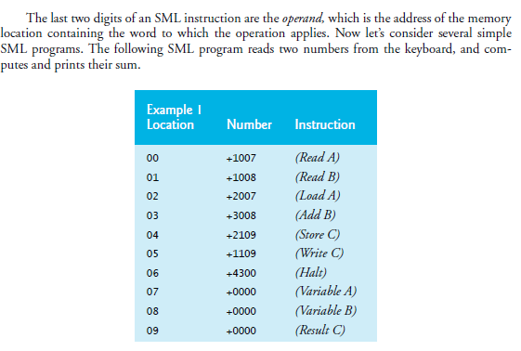

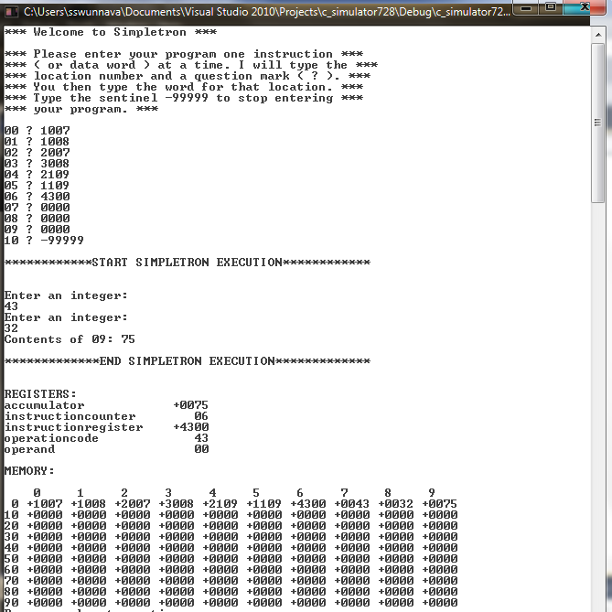

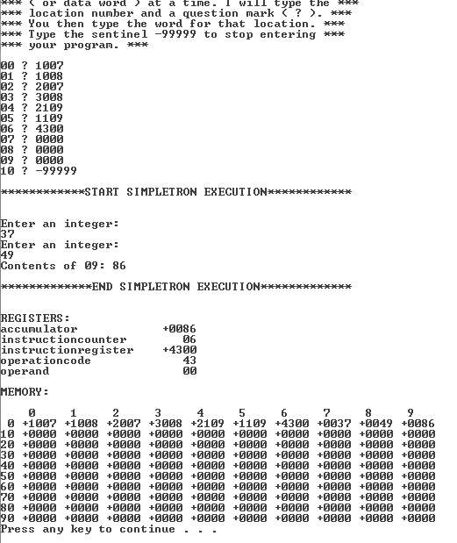

PROGRAM 2: Prints larger of the two numbers entered:

