Cancer, Demanding and Distressing Medical Condition
(03 25 10 04 21 10 05 07 10 07 01 2010)
INTRODUCTION
The word ‘Cancer’ has such frightening and devastating effect, not only on the patients, but also among the family members and friends. Even though there are medical advances and new strategies to sustain and fight the cancer condition, still people tend to think that their quality of life would be compromised, their finances would be diminished, and they would die, irrespective of the treatment. It has been my experience as a cancer patient, that having faith and positive attitude and cooperating with the medical teams and the families would have a dramatic impact on controlling the cancer, and leading a near normal life.
Cancer results in uncontrolled growth of cells, resulting in malignant tumors in the body. These malignant cells and tumors demand much more nutrition than the normal cells, and make the patient vulnerable for under nutrition, sickness, and ultimate death. There are so many different types of cancers, at different stages of advancement when the cancer conditions are discovered. Medical researchers around the world are constantly working hard to find causes, and improved treatments for cancer.

Cancer occurrences on rise due to smoking, food and other irregularities

While there are no good cancers, two types of cancers have been identified: “Aggressive Cancers” and “Non Aggressive Cancers”. In the first instance the cancer tumor grows, and spreads faster than the other type. If neglected, the non aggressive cancers could cause the same, or even more damage than the aggressive cancers. As per the 2009 statistics of the National Cancer Institute (NCI), the estimated new cancer occurrences (of both types) per year in the United States alone would be around 1.5 million during 2009/2010. This number would add to the existing cancer patients. About 560,000 people are expected to die per year in USA alone, due to cancer and related conditions (nearly half and half among males and females).
Even though these numbers are staggering, one can clearly observe that more people are also surviving cancer. To minimize the occurrence of cancer, it is always good to take preventive measures such as: refraining from smoking and alcohol; moderating on eating habits; and developing stress free life styles. Unfortunately cancer could strike people, irrespective of sex or age. If cancer should strike, cooperate with the medical teams and family members to fight against it. Abundance of information is available on the cancer related issues from the libraries, internet, NCI, and from your own doctor’s office. This information would help individuals to steer themselves through the negative feelings of cancer, and reduce the myths and fears of cancer.

Getting depressed is not a solution, but fight the cancer disease

It has always been human tendency to believe that cancer, or other such diseases would not strike them, but somebody else. While such a positive attitude is good, one should have the courage to accept any such occurrences, and put out a genuine fight against these diseases.
I have seen several of my relatives, friends, and colleagues, who were hit by cancer, but never surrendered themselves. Some of them, and their families had to go through very tough times, but always kept their good composure. Also, I have also seen some others, who were totally depressed and very fearful of the cancer disease, and had a very negative attitude. Apparently this group would make the lives of their beloved family members very difficult, and devastating. It is a very well known fact that fear would let people go down, and make them unnecessarily depressed; whereas courage and hope would provide determination, and the strength to stand up to any eventualities. I personally could attest to these facts, thanks to the wonderful support I have received from my family members and medical teams.
In my own case, after returning to my home town Miami in USA following a demanding international trip, I became sick with severe stomach pain and gastric difficulties, during early part of 2000. I was hospitalized for about 10 days, and was treated for gastric infections, and was released from the hospital. However, I had been experiencing recurring stomach pains and cramps, and at times rectal bleeding. I tried to control the pain by taking the pain killers. I self interpreted the rectal bleeding due to hemorrhoids (I had prior surgery for them years ago). I did not want to share my medical conditions with family members for fear of alerting and bothering them. May be, I also had an egoistic attitude that I could handle these medical conditions by myself.
Towards later part of 2000, my sickness became very acute, and I had to be taken to the emergency. Several doctors attended upon me, including my personal physician Dr. Alan Seifer (FIGURE 7.1) my gastroenterologist Dr. Pamela Garjian (FIGURE 7.2) and general surgeon Dr. Edelman (FIGURE 7.3). These doctors were highly professional, patient oriented and very knowledgeable, and provided me and my family with the comfort they needed at my acute sickness and hospitalization at the well reputed Baptist Hospital in Miami (FIGURE 7.4).
It was Dr. Garjian, whose persistence and her commitment to make the patient feel better, that discovered the Carcinoid Cancer condition in my intestine, with the help of tests like Colonoscopy and Endoscopy. The medical team decided that the cancer tumor was malignant, and had widely spread into the Terminal Ileum (the final segment of the small intestine ending in the large intestine (colon)). The cancer tumor had to be removed immediately through surgery, since it was too large for other procedures such as the Chemotherapy or the Radiation-therapy.
Even though I had put out a very bold show that I was not worried and bothered about the malignant cancer condition, I was internally very sad and a kind of depressed. My wife Sunanda was devastated at the news (we lost a couple of very close friends to cancer during that period). Our son Manoj just finished medical school and was taking up the residency. He interacted with the medical team, and explained to us the pros and cons of the surgery (the only treatment option I had), and convinced me, my wife Sunanda, and daughter Madhavi that I should go for surgical procedure. By then, I got back my composure and decided not to be depressed, since it would not serve any purpose, and even would unnecessarily stress the family members and the medical teams.

Taking advantage of surgical, chemo, and radiation treatments

Many cancer patients and families tend to waver between the different forms of treatments and therapies, confuse themselves, and also the medical teams. Adhering to the professional opinions of the well educated and experienced medical personal would sure guide the patients in the correct direction. In my own case, because of the extended spread of cancer into the terminal ileum, the only recourse I was left with was the surgery, and my family was fully supportive of the decision.
Within two weeks of my cancer diagnosis, I was scheduled for surgery. Dr. Joe Levi (FIGURE 7.5), distinguished professor of surgery at the University of Miami Medical School, and head of the surgical division was very compassionate and kind to conduct my cancer surgery on a very high priority basis. I learnt that Dr. Levi had made extra adjustments in his highly demanding schedule (also he postponed a pre arranged family event), to operate upon me, because of my critical and deteriorating cancer condition.
Dr. Deepika Dalal (FIGURE 7.6) was the chief anesthesiologist, and she was so compassionate and caring before, during, and after the surgical procedure. I was told that she stayed with surgeon Dr. Levi and assisted him during the entire surgical procedure, which lasted for more than 6 hours at the Jackson Memorial Hospital (JMH) in Miami (FIGURE 7.7), in coordination with the Sylvester Cancer Clinic. In spite of her overwhelming schedule, Dr. Deepika Dalal could find time to make regular visits to me and cheer up my family members during my entire stay in the hospital. One particular issue I learnt from her and Dr. Levi was to minimize the use of pain killers, and resort to bio feedback for pain management. Even today, after nearly 10 years of my surgery, I practice them.
Open discussions with surgeon Dr. Joe Levi few days before the actual surgery gave me moral courage and strength. In no uncertain terms, Dr. Levi explained me and our son Dr. Manoj Wunnava that he might have to remove the whole terminal ileum, parts of my small and large intestines, and possibly some lymph nodes, if they were affected by cancer. The lymph nodes are critical for the body's immune response and are principal sites where many immune reactions are initiated. As such, I would have to be very careful against infections, after the surgery.
Also, Dr. Levi and Dr. Garjian reiterated the fact that a one way valve between the interface of the small intestine at the terminal ileum (FIGURE 7.8) and the large intestine (called the Ileocecal valve) would have to be removed during the surgery. The function of this Ileocecal valve is to allow the digested food materials from the small intestine into the large intestine. It also blocks these waste materials from the large intestine from backing into the small intestine. There was no guarantee that this valve would grow back, and I might have to live rest of my life with reduced sizes of my intestines and without the valve. As such, I would have to be extremely careful with my food habits, and avoid any type of constipation.
In addition, I was told that I might not have enough production and storage of B-12 vitamin. B-12 is the primary catalyst for initiating the digestive process and producing the red blood cells, which in turn carry the oxygen and nutrients to all the parts of the body. This B-12 vitamin is usually obtained from foods like meat, cheese, fish, eggs, and other such items, and is absorbed by the intestines and the Terminal Ileum. Since my Terminal Ileum is going to be removed, I may have to take regularly B-12 supplements rest of my life (like Insulin for diabetic patients).
At the outset, I started feeling that my life was being doomed, and my quality of life would go down. However, I got back my composure immediately and appreciated the honesty of Dr. Levi and Dr. Garjian. Our son Manoj and daughter Madhavi, son-in-law Sanjai, and wife Sunanda gave me so much moral support and love, and pulled me out of my depression mode. The sayings of great people like Rabindra Nath Tagore (Nobel prize winner for literature 1913:FIGURE 7.9), Mother Teresa (Nobel prize winner for peace 1979: FIGURE 7.10) “Let the sufferance and hardships be mine; let the happiness and prosperity be for others near and dear”, gave me added courage and realization that I should take the condition like cancer, rather than anybody in my family.
My corcinaid cancer surgery went on very well at the Miami Jackson Memorial Hospital (JMH) in October 2000, with an extended stay for about 10 days in the hospital. Every day, surgeon Dr. Joe Levi, and anesthesiologist Dr. Deepika Dalal made regular visits, to ensure that my recovery was satisfactory. All my family members were with me before, during, and after the surgery. My recovery in the hospital was considered very substantial and progressive. Dr. Levi and Dr. Dalal used to bring their respective resident medical personnel to discuss with them my condition, recovery, and the demanding nature of my surgery. The medical team wanted to wait and observe the progress, before they would decide on the follow up chemo or radiation therapies.

Cooperating with the medical teams and family very important

In any sickness, post surgical and post hospitalization care (of the patient and by the patient) are as important as the respective procedures themselves, since they set the path for recovery and rehabilitation, for normal living. In my own case, the surgical team had to remove Ileocecal valve, all of my terminal ileum, along with some more additional small intestine segments(totaling about 45 – 50 Centimeters), some part of the colon (about 35-40 Centimeters), and several lymph nodes which were considered as cancer affected.
The amount of intestine removed was close to about 30% of the total length. Fortunately 70% of the intestine was still remaining. Following the square or quadratic law, 70% of intestine would provide only 49% of the original digestive capability [70% =>0.7; (0.7)² = 0.49]. For persons like me, that translated into taking less amount of food, more often (about 5-6 times a day than the normal 3 times a day). Also, to avoid constipation, more liquids such as water or diluted juices were to be taken. In the beginning, these adjustments bothered me and at times made me sad and irritant. My own family members gave up on their own food habits to follow those of mine, basically to provide me moral support. Soon I realized, I should not behave like a child demanding sympathies from my family and friends, and I made adjustments to my food and living habits to suit the medical requirements.
Dr. Pasquale Benedetto (FIGURE 7.11), equally distinguished professor of Oncology from University of Miami Medical School has taken over as my oncologist, after the surgery. Because of my delicate digestive capabilities, and because of the near removal of the cancer in the intestines, the medical team decided that it was not immediately necessary for chemotherapy. However, I would have to go to period checkups at 3-6 month intervals, blood tests, X-rays, and radiation flush based neo radio scans of the stomach, abdomen, and the intestines.
In addition, I was being regularly evaluated and monitored by my oncologist Dr. Benedetto, and gastroenterologist Dr. Garjian. Any suspected growth would be dealt with colonoscopy and endoscopy type of procedures, with laser burning of the polyps in the intestines. My Ileocecal valve has not grown back even after 10 years. With the result, as per the instructions of my oncologist Dr. Benedetto, I have been extremely careful about my food habits and maintain my weight within a specified window.
Around 2007/2008 time frame, I started complaining about short lived but shooting pains in my stomach. Dr. Benedetto discovered that it was the formation of “Scar Tissue” in my intestine where I was operated, that was causing my deep discomfort. He, in consultation with my gastroenterologist Dr. Garjian and with my surgeon Dr. Levi suggested that I should not opt for surgical procedure to remove the scar tissue, unless it becomes cancerous. There is absolutely no guarantee that the scar tissue would not grow back, even after surgical removal. As such, with encouragement, help and guidance from Dr. Benedetto, I have learnt to live with the scar tissue formation in my intestines. I skip a meal or two and go on liquid diet whenever I feel the stomach discomfort. So far it has been working.
The courage, determination, and message to the world as not to give up, delivered by Professor Randy Pausch, before his cancer death in July 2008, and his “Last Lecture” at the Carnegie Mellon were truly inspirational. They helped millions of cancer patients like me around the world to come to terms and fight the cancer disease. He lived by example of what he said, until the very end.
Before my cancer surgery, I had donated 8 gallons of blood, and always felt good about it. I was disqualified after the surgery to donate blood, and I felt sad. However, Dr. Benedetto suggested that persons like me could do other types of medical oriented social service such as getting involved in the Cancer Support Groups, and helping the needy people. I should admit that in the beginning, I was not too thrilled to be a part of these support groups, because of the associated agony and sadness with cancer patients and families. Soon I got over that negative attitude, and I feel so good and productive to be a part of these support groups and activities.
SUMMARY
No doubt, cancer is a very depressing and demanding disease. There are approximately 1.5 million new cases of cancer occurrence each year in USA alone, and about 560,000 patients are expected to die. There are so many different types of cancers, aggressive and non aggressive types, and at different levels of progress at the time of detection. In a nut shell, cancer refers to the uncontrolled growth of cells, resulting in malignant tumors. These malignant tumors absorb line’s share of the body nutrition, leaving other cells and organs dried out. This would ultimately result in the under nutrition, other forms of sickness, and death.
However, on the bright side, several forms of cancer are being controlled, and even cured, if detected early. Also, continuous global research on cancer is resulting in new methodologies of treatment, and identifying the actual causes for cancer occurrence. Hopefully, some kind of cancer vaccination may also be a reality as a result of the extensive cancer research.
One should never get depressed at the occurrence of cancer, since such depression and negative attitudes would make the fight against cancer very difficult and futile, and also would load down the medical teams and families of the cancer affected patients.
It is always good to observe the fundamental rules of health and food intake to minimize the cancer occurrences. Also, adherence to the medical advice, and associated medical treatments of surgical procedures, and follow up chemo and radiation therapies would sure help. Cancer support groups offer a tremendous amount of solace and confidence in fighting the disease.

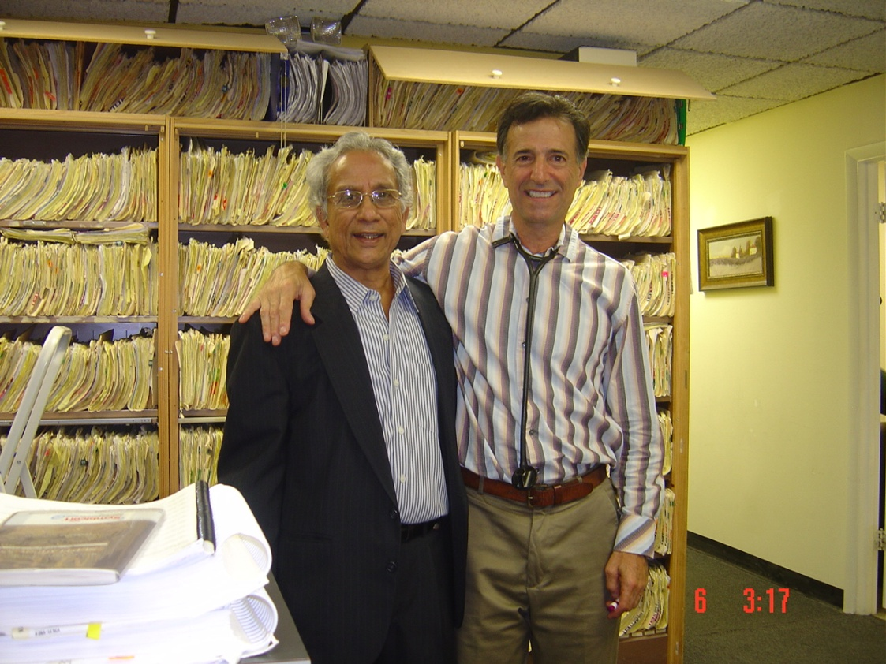
FIGURE 7.1: Subbarao with his physician for 35 years, Dr. Alan Seifer, who has taken care of him all
these years through different medical conditions (photo 2010)
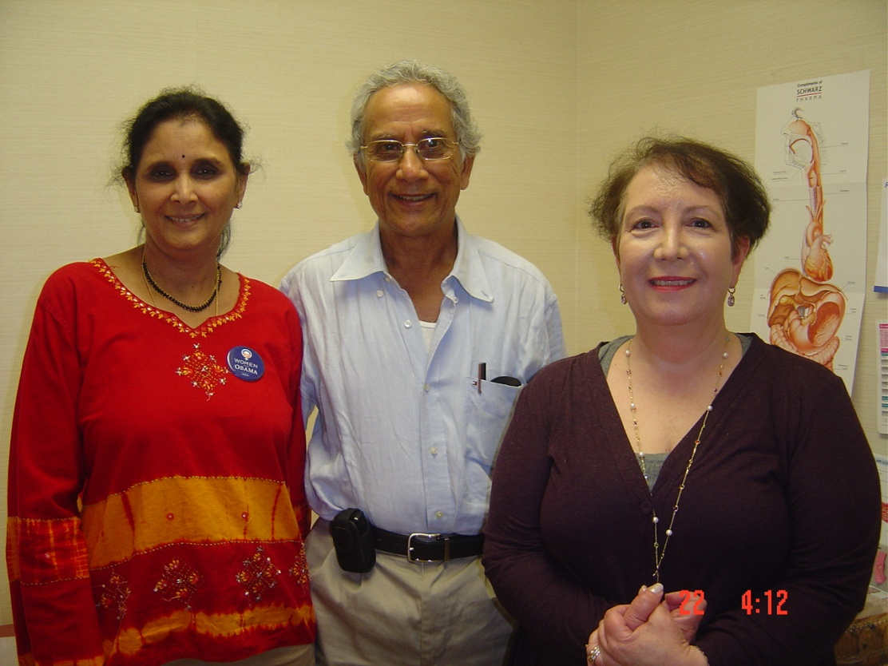
FIGURE 7.2: Subbarao with his wife Sunanda (left) and his Gastroenterologist Dr. Pamela
Garjian (right), who found Subbarao’s cancer and has been treating him since then (2010 photo)

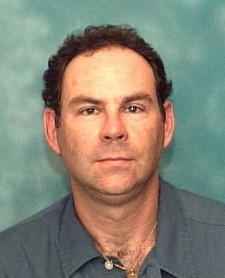

FIGURE 7.3: Dr. David Edleman, general surgeon at Baptist hospital who treated Subbarao with care and compassion during his gastro related emergency hospitalizations (photo 2010)

FIGURE 7.4: Baptist Hospital in Miami, where Subbarao was hospitalized and treated for
Pre and pro cancer surgical procedures.

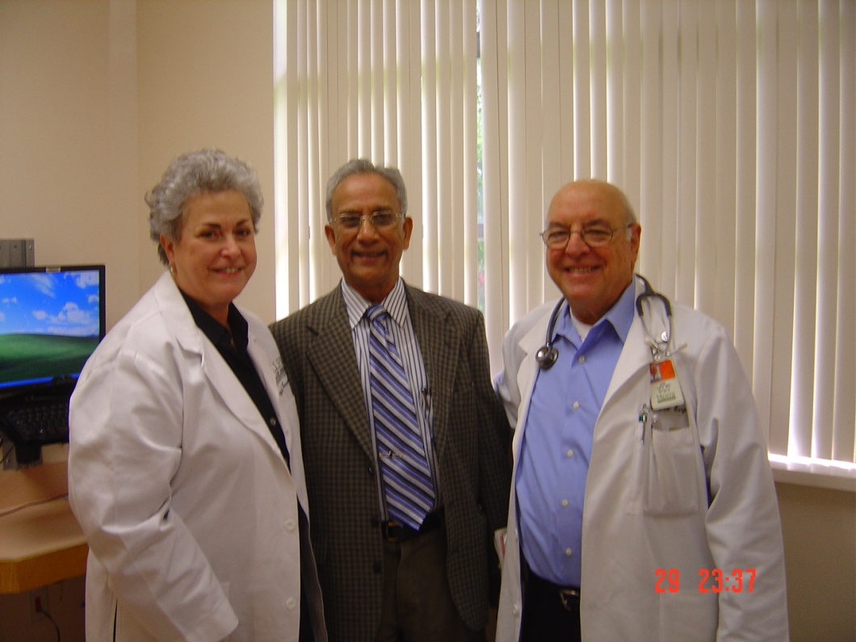

FIGURE 7.5: Subbarao with his highly demanding and compassionate cancer surgeon
Dr. Joe Levi (right) and his wife Mrs. Linda Levi (office manager). Dr. Levi periodically
Monitors Subbarao’s progress and the CT scans

FIGURE 7.6: Chief anesthesiologist Dr. Deepika Dalal, always on the mission to help and make the patients feel better and at home, even in a tiring hospital environment

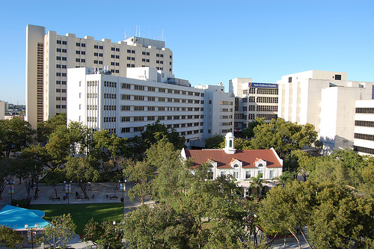

FIGURE 7.7: Jackson Memorial Hospital where Subbarao’s cancer surgery took place in 2000

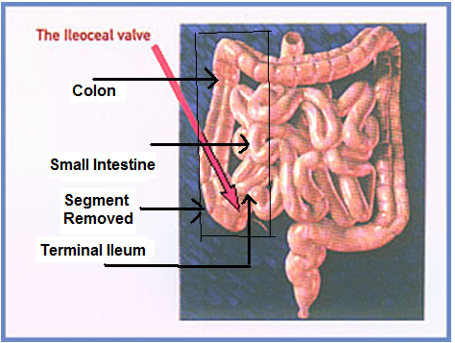

FIGURE 7.8 Terminal Ileum, small and large intestines, and the Ileoceal valve. Box shows the
Cancer segment removed surgically for Subbarao

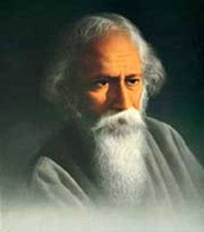
FIGURE 7.9: Nobel Laurate Rabindranath Tagore, whose words of wisdom and
Compassion would alwayslift people from negative thoughts and sadness

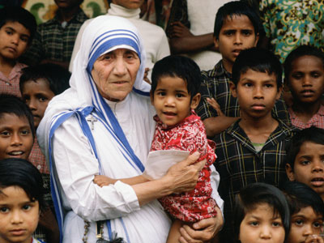

FIGURE 7.10: Bobel Laurate Mother Teresa whose unconditional love, affection, and caring
for needed, under privileged, and all the human race would always show a path
for love and progress

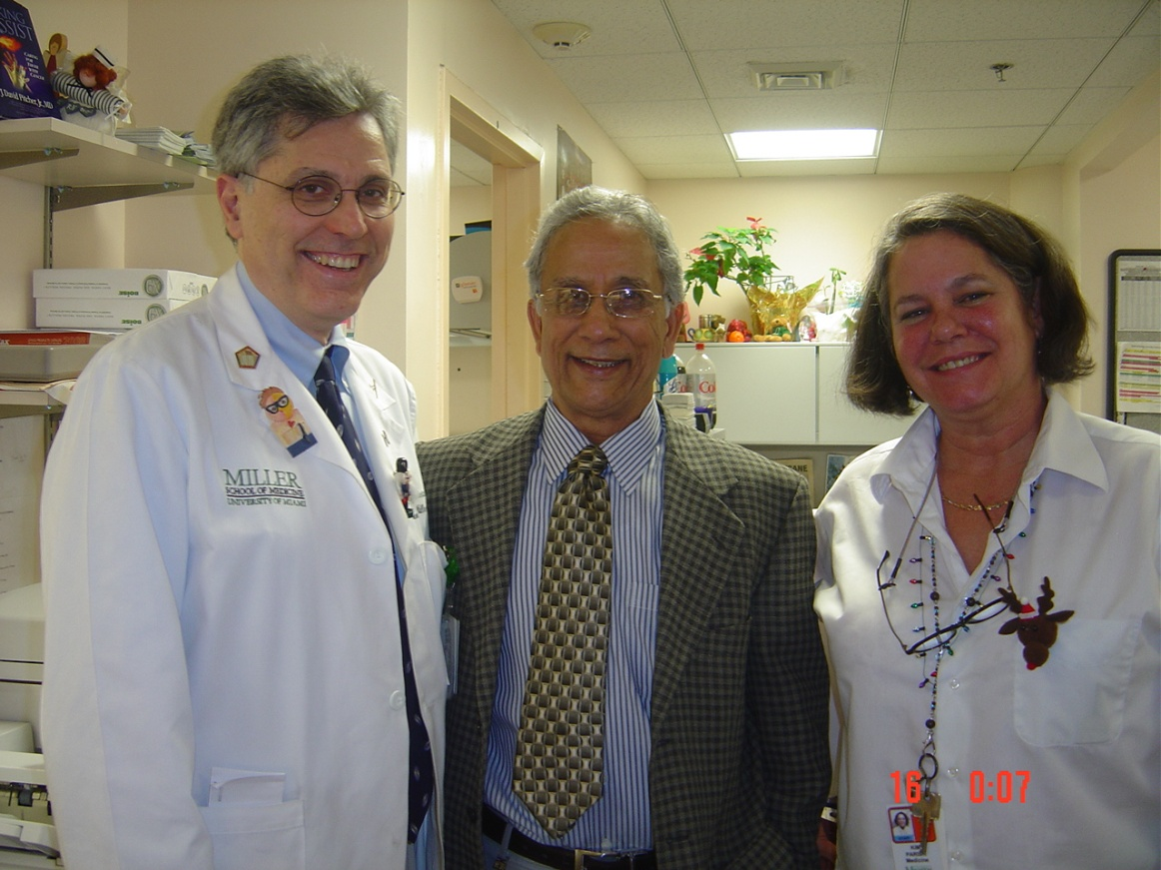

FIGURE 7.11: Most compassionante and distinguised professor of Oncology Dr. Benedetto (Left), who
has been taking care about Subbarao, with Ms. Kim Parish, the office manager (2010)

