EEL 3110: Circuit Analysis: Circuit Simulations: Project 1 : 01 30 2020
Subbarao V Wunnava: Reference Chps: 1-6: Nilsson: and chps 1-5 Ulaby

Objective: To comprehend the principles of circuit analysis and correlate the results with the simulation tools such as Multisim, Pspice, and to promote team work:
General Considerations:
- Class of 02 13 2020 Thursday Delegated for project coordination: No formal class
- You may form into groups of no more than 3
- You may use Multisim, Pspice or any other similar software platform
- Perform hand calculations and then compare them with your simulation results
- Formal report due Thursday 02 20 2020, at the beginning of the class, per team

Problem 1: Shown is a circuit with two independent current sources IX, IY, and 4 resistances R1 R2 R3 and R4. Use circuit simulations with Multisim or Pspice, or any other simulation tool of your choice. Find the nodal voltages V1 and V2 and currents IR1 IR2 IR3 IR4 through R1 R2, R3, and R4, and the powers P1, P2, P3, P4 dissipated in R1 through R4; and powers Px and Py associated with IX and IY sources [given out or absorbed, why].
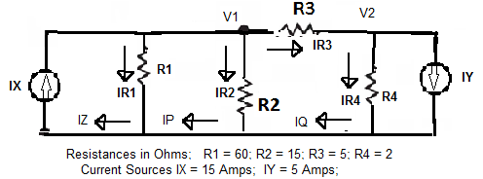
Problem 2:
Repeat Problem 1, when the resistance values are doubled from Problem 1 and compare results to problem 1.
Problem 3:
Repeat Problem 1, when the resistance values are halved from Problem 1 and compare results to problem 1.
Problem 4: Digital to Analog Converter
Design Op. Amp based 3 bit Digital to Analog Converter, to provide analog output from
0 volts to 8 volts for 000 to 111 condition of the input signals. Consider input to be 0 volts or
1 volt each. Extend the design to 8 bit D/A providing 0 volts output for all 0 condition of
Inputs; to 15 volts output for all 1 condition of the inputs.

Courtesy: Mr. Carlos Velez and Mr. Tony Rubio, and Mr. Mike Abadia, Volunteer TAS

