DIFFERENCE AMPLIFIERS

Also known as differential amplifiers. Ideally responds to the differential voltage and rejects the common mode voltage. Practical circuits will have a combination of both modes.

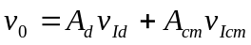  The efficacy is usually measured thru the common mode rejection ratio.  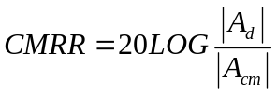 | 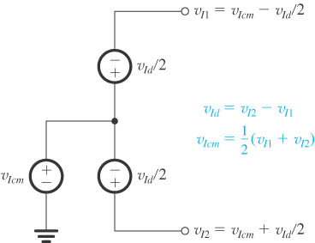

Single Op-Amp Difference Amplifier

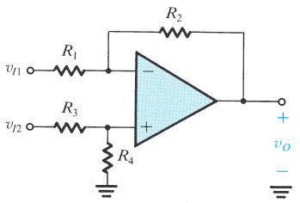 | 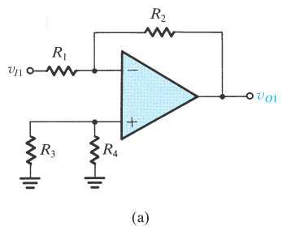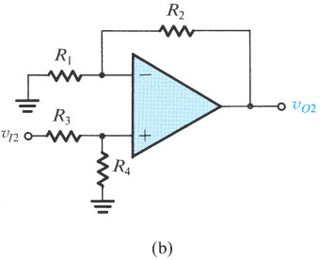

The common Mode Gain and the Differential Input Resistance

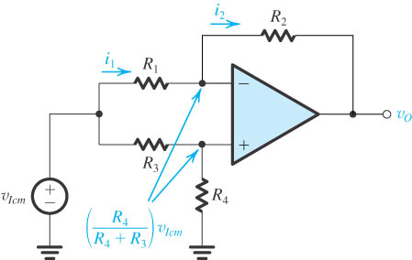 | 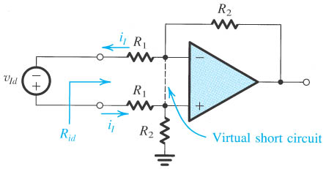

When then , on the other hand,

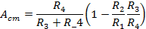
The Instrumentation Amplifier

We can increase the low input resistance by using two buffers at the inputs, but we could also add some gain to these input circuits and ease the gain burden of the difference amplifier.

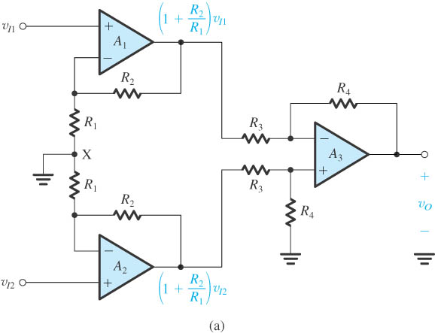 | 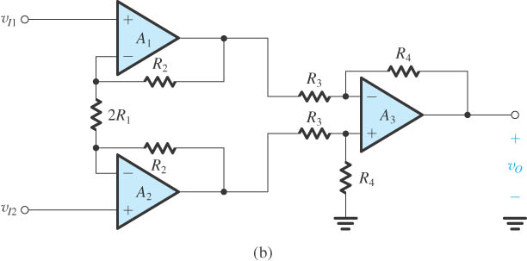
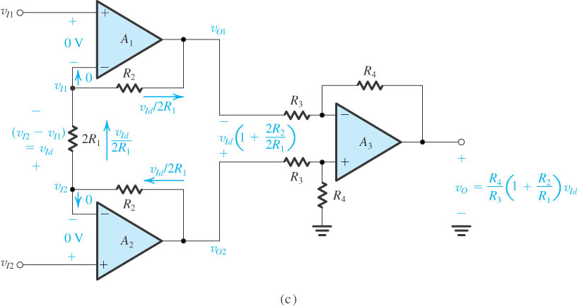

Common Mode Rejection

For 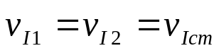, the current thru 2R₁ is 0 and therefore the voltage passes thru those amplifiers with no amplification which is an advantage for the CMMR.
EFFECT OF FINIE OPEN-LOOP GAIN AND BANDWIDTH ON CIRCUIT FERFORMANCE

Frequency Dependence of the Open-Loop Gain

Expressing Gain in Decibels.

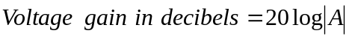

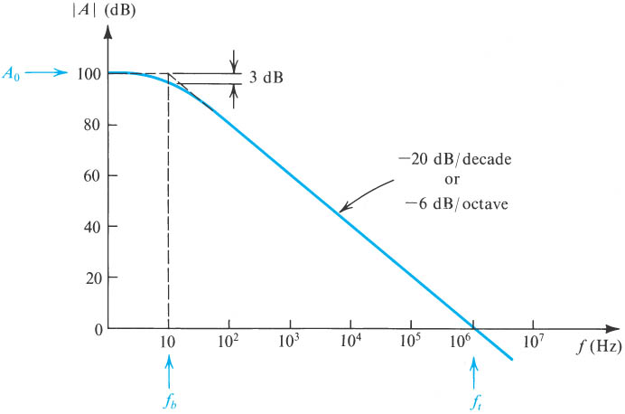
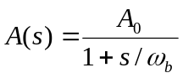

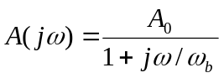

At high frequencies, 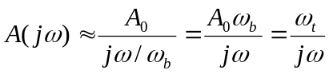

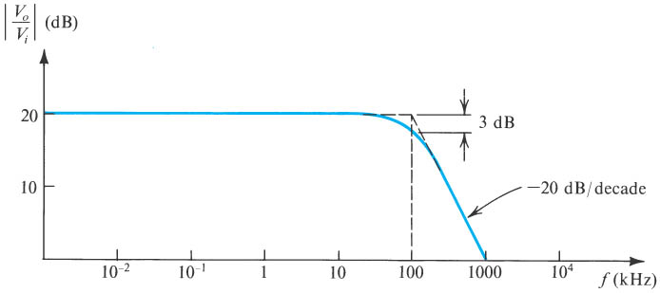 | 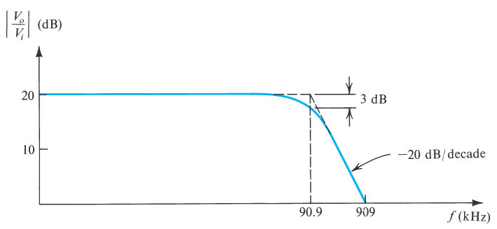
Nominal Gain + 10 V/V | Nominal Gain -10 V/V
ft = 1mHz. Find the 3-dB frequency of the closed loop amplifiers. | 

